

Session: July to December–2025

Project Progress Report

Project Title: AI-RESUME ANALYZER

Guided By: Submitted By:
Name: MR Animesh Sarkar Name of Students & Roll No.

Designation: Assistant Professor (CSE) BCET

- Ashish Sinha (12500122117)
- Ankit Raj (12500122112)
- Sanket Kumar (12500122069)

Department of Computer Science and Engineering
Submission Date: …………………..

Table of Contents

Abstract Project Outline
Problem Insights Chapter 1
Project Title Project Overview Project Aims
Benefit of your Project in context to the need of society
Impact of project in context of environment and sustainable development Work Breakdown structure
Module Description

Chapter2ProgresstillDate
Data Analysis
Requirement Analysis(SRS) Functional Requirement Non-Functional Requirement Software Design
Dataflow Diagram
Structural Diagrams(whichever is applicable) Class Diagram
Architecture Diagram Behavioral Diagrams
Use-Case Diagram Sequence Diagram
Database Diagrams ER Diagram DFD
Algorithm

Chapter3TasksRemaining
Elaborate the remaining work allotment with name of members Scheduling of remaining work

0 References 5.0ReportEvaluationSheet

Project Outline:

1.1 Project title
1.2 Group members  (List names along with university roll no. and roles defined for project) | Member Name and Enroll No. Role
 |  | 1. | Ashish Sinha (12500122117) | FRONTEND DEVELOPER AND BACKEND  DEVELOPER
 |  | 2. | Ankit Raj (12500122112) | API
 |  | 3. | Sanket Kumar (12500122069) | FRONTEND
1.3 Technical  advisor(s)  (As officially assigned) |  | 4.
Name of Guide:
Name: Mr Animesh Sarkar Designation: Assistant Professor (CSE)
Co-Guide(if any):
Name:

Designation:

External advisors(if any):
- Name: Designation:

Company/Institute:

- Name:
Designation:

Company/Institute:

1.4 CERTIFICATE

“This is to certify that the final year project work until first progress report evaluation held on ,titledasstatedinSec.1.1,executed (as till date) by the students’ group mentioned in Sec. 1.2, has been found satisfactory and every section of this report is reflecting the same.” | (Signature of Guide with date)

- Project in sights:

2.1 Thematic  area(s) | Research S/W Development Industry Automation Institute Automation  Other(please specify):
Sub-areas(optional):
Mobile Programming Web Programming HCI Data Mining Networking Image Processing Other
(please specify):
2.2 Keywords
(Max.3to6.Don’t use abbreviation)
2.3 Utilization scope | Domestic |  | Commercial |  | Industrial |  | Scientific
 | Global National State District Institute University External Sponsor
 | Other(please specify):
2.4 Major task(s)  (At least one should be checked) | Modeling S/Designing fabrication Testing Optimization Consultancy document Physical tool(s) development  Others(please specify):
2.5 Software  packages, tools and programming languages | MSExcel VBA C/C++/C# Python  FullStack Angular Java EES  HTML DSA VB Java PH ASP/.NET  Oracle SAP MySQL SQL Mobile phone development (please specify):
 | Others(please specify):

CHAPTER1
Project Title: AI Resume Analyzer
The AI Resume Analyzer is a full-stack web application designed to evaluate résumés using advanced Artificial Intelligence and NLP models.
The system extracts text from uploaded résumés, compares it with a job description, identifies matching and missing skills, computes ATS (Applicant Tracking System) compatibility score, and generates personalized suggestions for improvement.
The backend is built using Python (Flask) with NLP-based keyword extraction and scoring logic. The frontend uses HTML, CSS, and JavaScript with a modern responsive UI.
The system helps job seekers optimize their résumés and increase their chances of getting shortlisted.

Project Aims
To develop an AI-powered résumé evaluation tool to analyze skills, keywords, and job match score. To automate résumé text extraction using NLP and document parsers.
To compute ATS score based on JD (Job Description) and résumé similarity. To provide personalized improvement suggestions to users.
To create a clean, responsive, and user-friendly interface.
To build a scalable system that supports various file formats (PDF/DOCX).
Benefit of the Project in Context to the Need of Society






Helps job seekers prepare ATS-friendly résumés.
Saves time by instantly analyzing résumé strengths/weaknesses. Provides equal job opportunities through unbiased AI-based evaluation. Reduces dependency on professional résumé writers.
Helps freshers understand required skills for targeted job roles. Enhances hiring efficiency for companies.




Impact in Context of Environment & Sustainable Development Completely digital process reduces paperwork and printed résumés. Encourages online job applications, reducing transportation and logistics.
Supports UN SDG-8: Decent Work and Economic Growth by improving employability. Minimizes resource usage by automating manual résumé screening.

Work Breakdown Structure (WBS)

Phase | Task | Responsibility | Timeline
Phase 1 | Project Planning and Requirements | Team Lead | Week 1-2
Phase 2 | Backemd Setup (Flask APIs,Text Extraction,NLP) | Backend Developer | Week 3-5
Phase 3 | ATS scoring Logic and Skill Matching | AI Engineer | Week 6-8
Phase 4 | Frontend Development (HTML, CSS, JS) | Frontend Developer | Week 9– 11
Phase 5 | Dashboard, Score Animation, UI/UX | Full-Stack Dev | Week 12– 14
Phase 6 | Testing & Debugging | QA Team | Week 15– 16
Phase 7 | Deployment & Report Preparation | All Members | Week 17– 18

Module Description:

Module Name | Description
Resume Upload Module | Allows users to upload PDF/DOCX files. Performs file validation.
Text Extraction Engine | Extracts text from documents using NLP tools.
Job Description Parser | Extracts keywords and skill requirements from JD.
ATS Scoring Module | Computes ATS percentage based on keyword match.
Skill Matching Module | Identifies found skills and missing skills in the résumé.
AI Suggestions Module | Generates personalized improvement tips
Result Dashboard Module | Displays score, skill match, missing skills, suggestions in a clean UI.
Dark/Light Mode UI | Improves accessibility and user experience.

CHAPTER 2
Data Analysis (AI Resume Analyzer)
The AI Resume Analyzer processes structured and unstructured data to extract résumé content, analyze job descriptions, match skills, compute ATS score, and recommend improvements.
Data is classified into the following categories:

Data Type | Source | Purpose
User Data | Resume file upload (PDF/DOCX) | Extracting personal details,experience, education, and skills.
Job Description Data | Text pasted by user | Keyword extraction, required skills identification, role matching.
Skill Dataset | Predefined skills.json file | Mapping job skills with résumé content.
ATS Analysis Data | Extracted resume text + JD keywords | Score calculation, skill comparisons.
Suggestions Data | AI-generated improvement  suggestions | Enhancing résumé quality and ATS compatibility.

The system uses NLP, keyword extraction, and AI-assisted scoring techniques to compare résumé content
Requirement Analysis (SRS)
    - Introduction
The Software Requirement Specification (SRS) defines the functionality, performance, and constraints of the AI Resume Analyzer System.
The SRS ensures that the system provides accurate ATS analysis, stable performance, and a smooth user experience.

    - Functional Requirements
Requirement ID | Description
FR1 | The system shall allow users to upload résumés in PDF or DOCX format.
FR2 | The system shall extract text from uploaded résumés using NLP/document parsers.
FR3 | The system shall allow users to paste a Job Description (JD) for comparison.
FR4 | The system shall identify required skills from the JD using keyword extraction.
FR5 | The system shall match résumé skills with JD skills and calculate ATS score.
FR6 | The system shall display found skills, missing skills, and match percentage.
FR7 | The system shall generate AI-based suggestions for résumé improvement.
FR8 | The system shall provide a responsive user interface with dark/light mode support.
FR9 | The system shall return results instantly via a Flask API endpoint.
FR10 | The system shall show a dashboard with ATS score animation and skill insights.

    - Non-Functional Requirements

Requirement ID | Description
NFR1 | Performance: ATS results should load within 1–2 seconds.
NFR2 | Accuracy: Skill extraction and matching should maintain at least 90% correctness
NFR3 | Scalability: Support for large résumé files (up to 5MB).
NFR4 | Security: The system shall sanitize inputs and securely handle file uploads.
NFR5 | Usability: UI must be clean, intuitive, and accessible on all devices.
NFR6 | Maintainability: Codebase must follow modular structure (Flask routes, JS modules).
NFR7 | Compatibility: The system should work on all major browsers (Chrome, Firefox, Edge).
NFR8 | Reliability: System uptime must be consistent during analysis operations.

.

2.3 Software Design
The AI Resume Analyzer is designed using a modular and layered architecture, combining frontend, backend, NLP logic, and file processing layers. The design focuses on:
✔ Scalability
Easily expandable for future features (PDF preview, AI résumé rewriting, etc.).
✔ Maintainability
Divided into modules: extractor.py, scorer.py, suggestions.py.
✔ Security
Protects file uploads and prevents code injection.
✔ Performance
Fast text parsing and ATS calculation.

System Architecture Components
- Frontend (HTML, CSS, JavaScript)
- Resume upload
- JD input box
- Dashboard (ATS score, skill match)
- Dark/Light mode UI
- Fetch API integration
- Backend (Flask Framework)
- Analyze API endpoint
- Text extraction module
- Skill matching logic
- JSON response output
- NLP & Logic Layer
- Resume text extractor (PyPDF2/docx2txt)

- Job description keyword parser
- Skills comparison engine
- ATS score generator
- Skill Dataset
- Contains predefined list of technical skills, soft skills, tools, frameworks.
- Output Layer
- ATS Match %
- Found Skills
- Missing Skills
- AI Suggestions

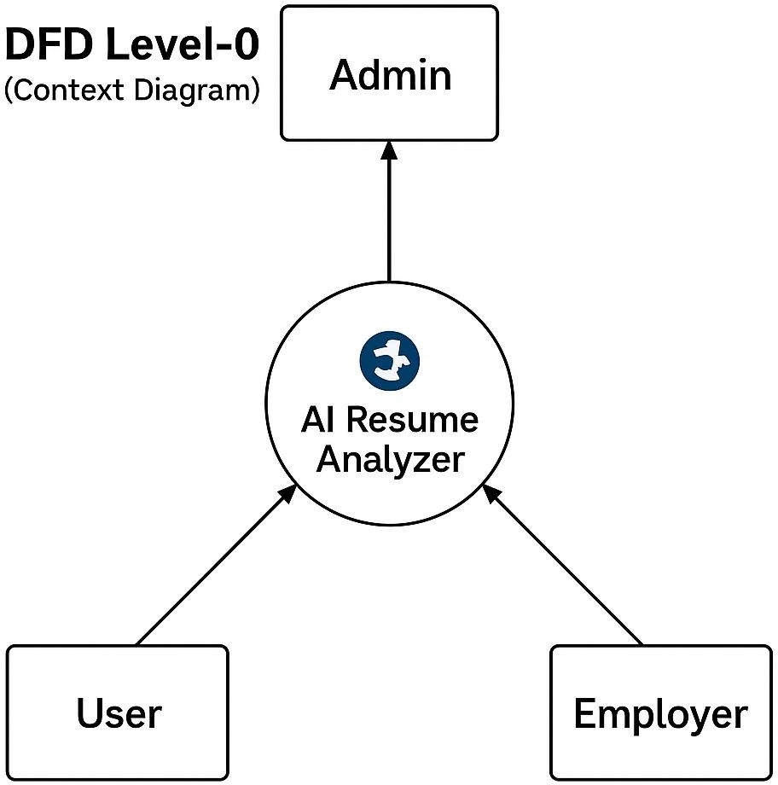
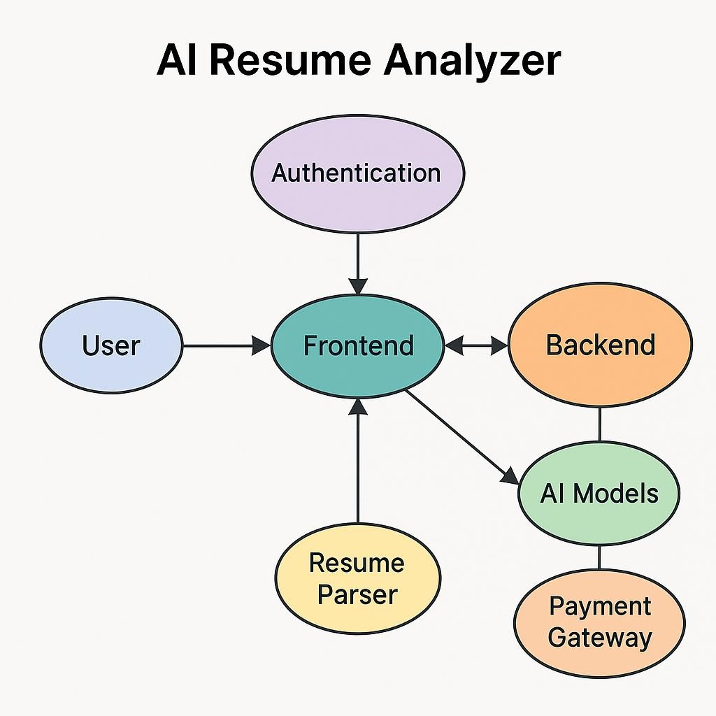

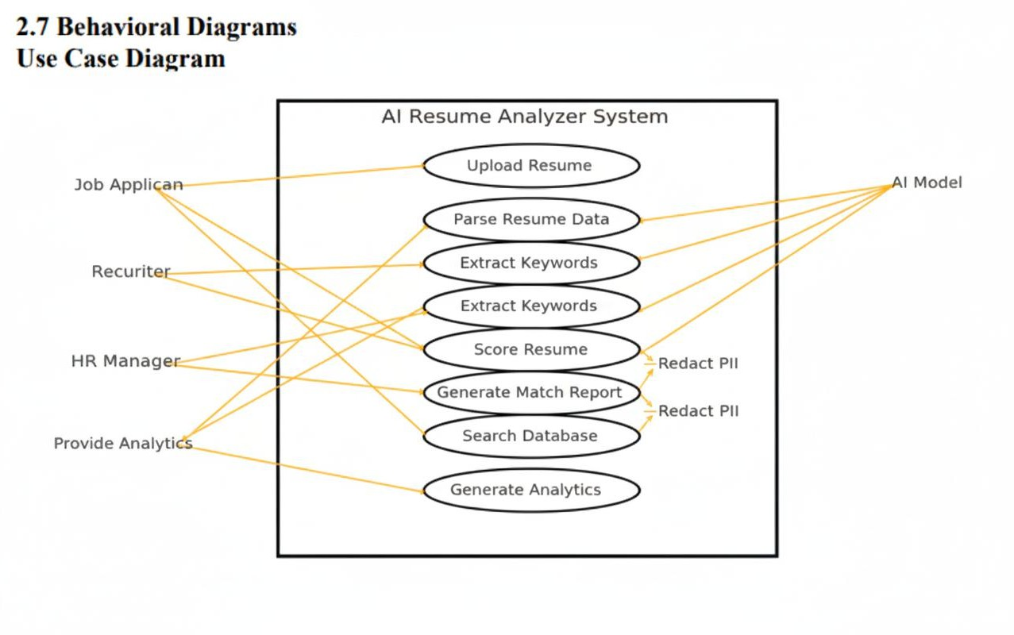
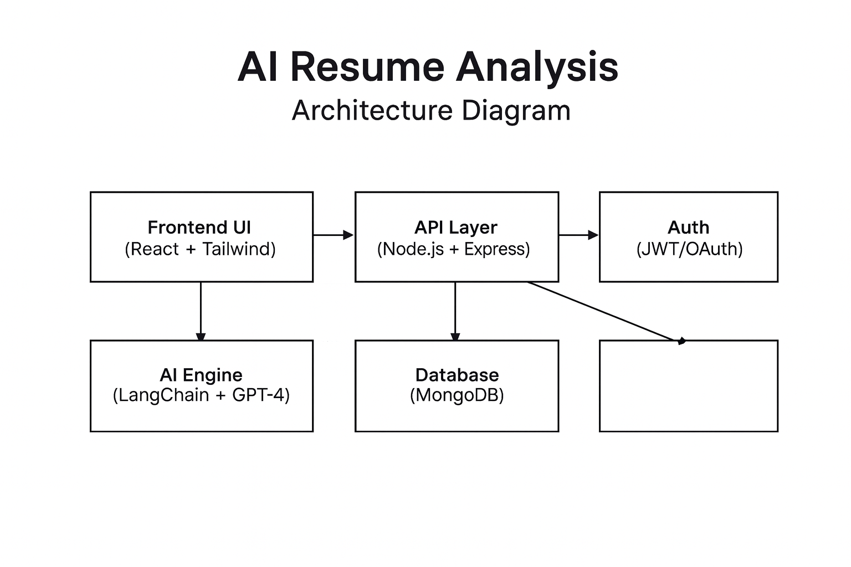

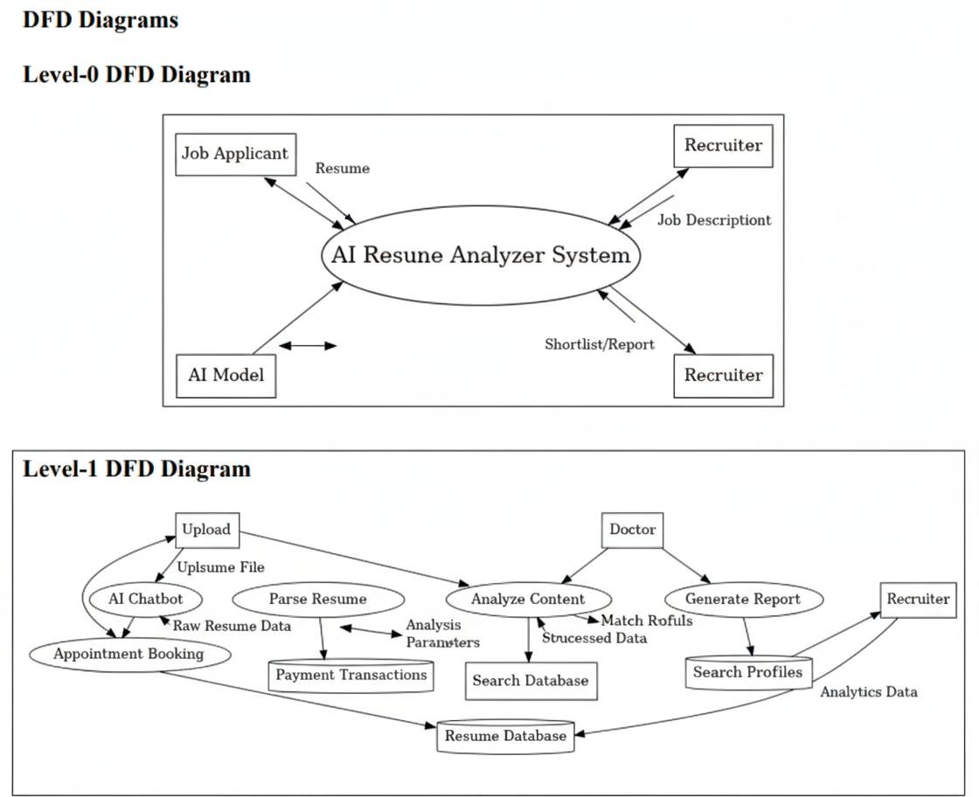

CHAPTER 3
Remaining Work Overview

Category | Remaining Task | Description
Frontend | User Dashboard | Build dashboard for users to upload resumes, track  analysis history, and receive recommendations.
 | Admin Panel | Create admin interface to monitor users, payments, and logs.
 | Responsive UI | Ensure full compatibility across mobile, tablet, and desktop using React + Tailwind CSS.
Backend | Resume Parsing & Scoring API | Finalize APIs for resume extraction, keyword matching, ATS score calculation, and job-fit scoring.
 | Payment Integration | Integrate Razorpay/Stripe (Test Mode) for  premium resume reports and subscription.
 | Authentication System | Implement secure login/signup using JWT +  OAuth (Google Sign-In).
AI Integration | Auto-Generated Text | Generate job-ready summaries, achievements,  bullet points, and cover letters using LLMs.
 | RAG Optimization | Improve accuracy by retrieving job-specific keywords, skills, and role descriptions.
 | Gemini / GPT Integration | Use Gemini/GPT for analyzing resumes, matching job descriptions, and generating improvement suggestions.
Extra Modules | Job Description Matching | Match candidates' resume with job description and  provide similarity score.
 | Resume Template Generator | Allow users to generate downloadable ATS- friendly resume templates.
Testing & Deployment | Unit & Integration Testing | Use Jest/Mocha for backend; React Testing Library for frontend.

3.2 Work Allotment Among Team Members
Member Name | Role / Responsibility | Tasks Assigned
Ashish Sinha | Frontend Developer | Develop user dashboard, admin panel UI, resume upload UI, responsive layout, and integration with backend APIs
Ankit Raj | AI | Integrate Gemini/GPT, implement auto-text generation, payment gateway setup, deploy backend/frontend on cloud
Sanket Kumar | Backend Developer | Manage MongoDB models, authentication (JWT/OAuth), payment APIs, resume analysis API, and RAG pipeline.

3.3 Scheduling of Remaining Work

Phase | Module / Activity | Responsible Member(s) | Timeline
Phase 1 | Complete Authentication System, User Dashboard & Admin Panel | Frontend + Backend Team | Week 1–2
Phase 2 | Integrate Resume Parsing API, Job Match System & Notification Emails | Backend Team | Week 3– 4
Phase 3 | Implement Payment System + Auto-Generated Text Features (LLM Integration) | AI & Integration Lead | Week 5–6
Phase 4 | Testing (Frontend + Backend), Bug Fixing & Performance Optimization | QA Team | Week 7– 8
Phase 5 | Final Deployment, Report Writing & Submission | Entire Team | Week 9

REFERENCES
- OpenAI, “GPT Models and API Documentation,” OpenAI Developer Documentation, 2024. Available: https://platform.openai.com/docs
- Google, “Gemini API – Multimodal AI Models,” Google AI Studio Documentation, 2024. Available: https://ai.google.dev
- LangChain, “Building LLM-Powered Applications,” LangChain Framework Documentation, 2024. Available: https://python.langchain.com
- MongoDB, “MongoDB Developer Manual,” NoSQL Database Documentation, 2024. Available: https://www.mongodb.com/docs
- ReactJS, “React Official Documentation,” Meta Platforms, 2024. Available: https://react.dev
- Tailwind CSS, “Utility-First CSS Framework,” Tailwind Documentation, 2024. Available: https://tailwindcss.com/docs
- Node.js, “Node.js v20+ API Documentation,” OpenJS Foundation, 2024. Available: https://nodejs.org/en/docs
- Express.js, “Fast Node.js Web Framework,” Express Documentation, 2024. Available: https://expressjs.com
- JWT (JSON Web Tokens), “JWT Introduction & Usage Guide,” Auth0 Documentation, 2024. Available: https://jwt.io/introduction
- Razorpay, “Payment Gateway Integration Guide,” Razorpay Developer Documentation, 2024. Available: https://razorpay.com/docs
- Stripe, “Online Payment API Documentation,” Stripe Developer Portal, 2024. Available: https://stripe.com/docs
- Python-PDF Libraries, “pdfminer, PyMuPDF & NLP Extraction,” Python.org Documentation, 2024. Available: https://docs.python.org

NLP Keyword Extraction Methods, “TF-IDF, Cosine Similarity & Embedding-
Based Matching,” ACM Digital Library, 2023.

Stream/Agora, “Video Call & Real-Time Communication API,” Agora Developer Docs, 2024. Available: https://docs.agora.io
- W3C, “Web Accessibility Guidelines,” World Wide Web Consortium, 2024. Available: https://www.w3.org

Report Evaluation Sheet
Please give marks out of 10 in each section, each member, if group got less than 40% marks then they require a revision.

Section | Marks Given By Guide | Marks Given By Project Coordinator | Marks Given by Convener
1. Project identification
2. Project insights
3.Relevantstudy material
4. Objective/Scope
5. Expected outputs
6. Utilization
7.Literaturestudy/Data collection
8. Methodology
9.Executedwork
10.Remainingwork
Overall performance
Signature and date

Signature
Head of Department CSE, BCET

